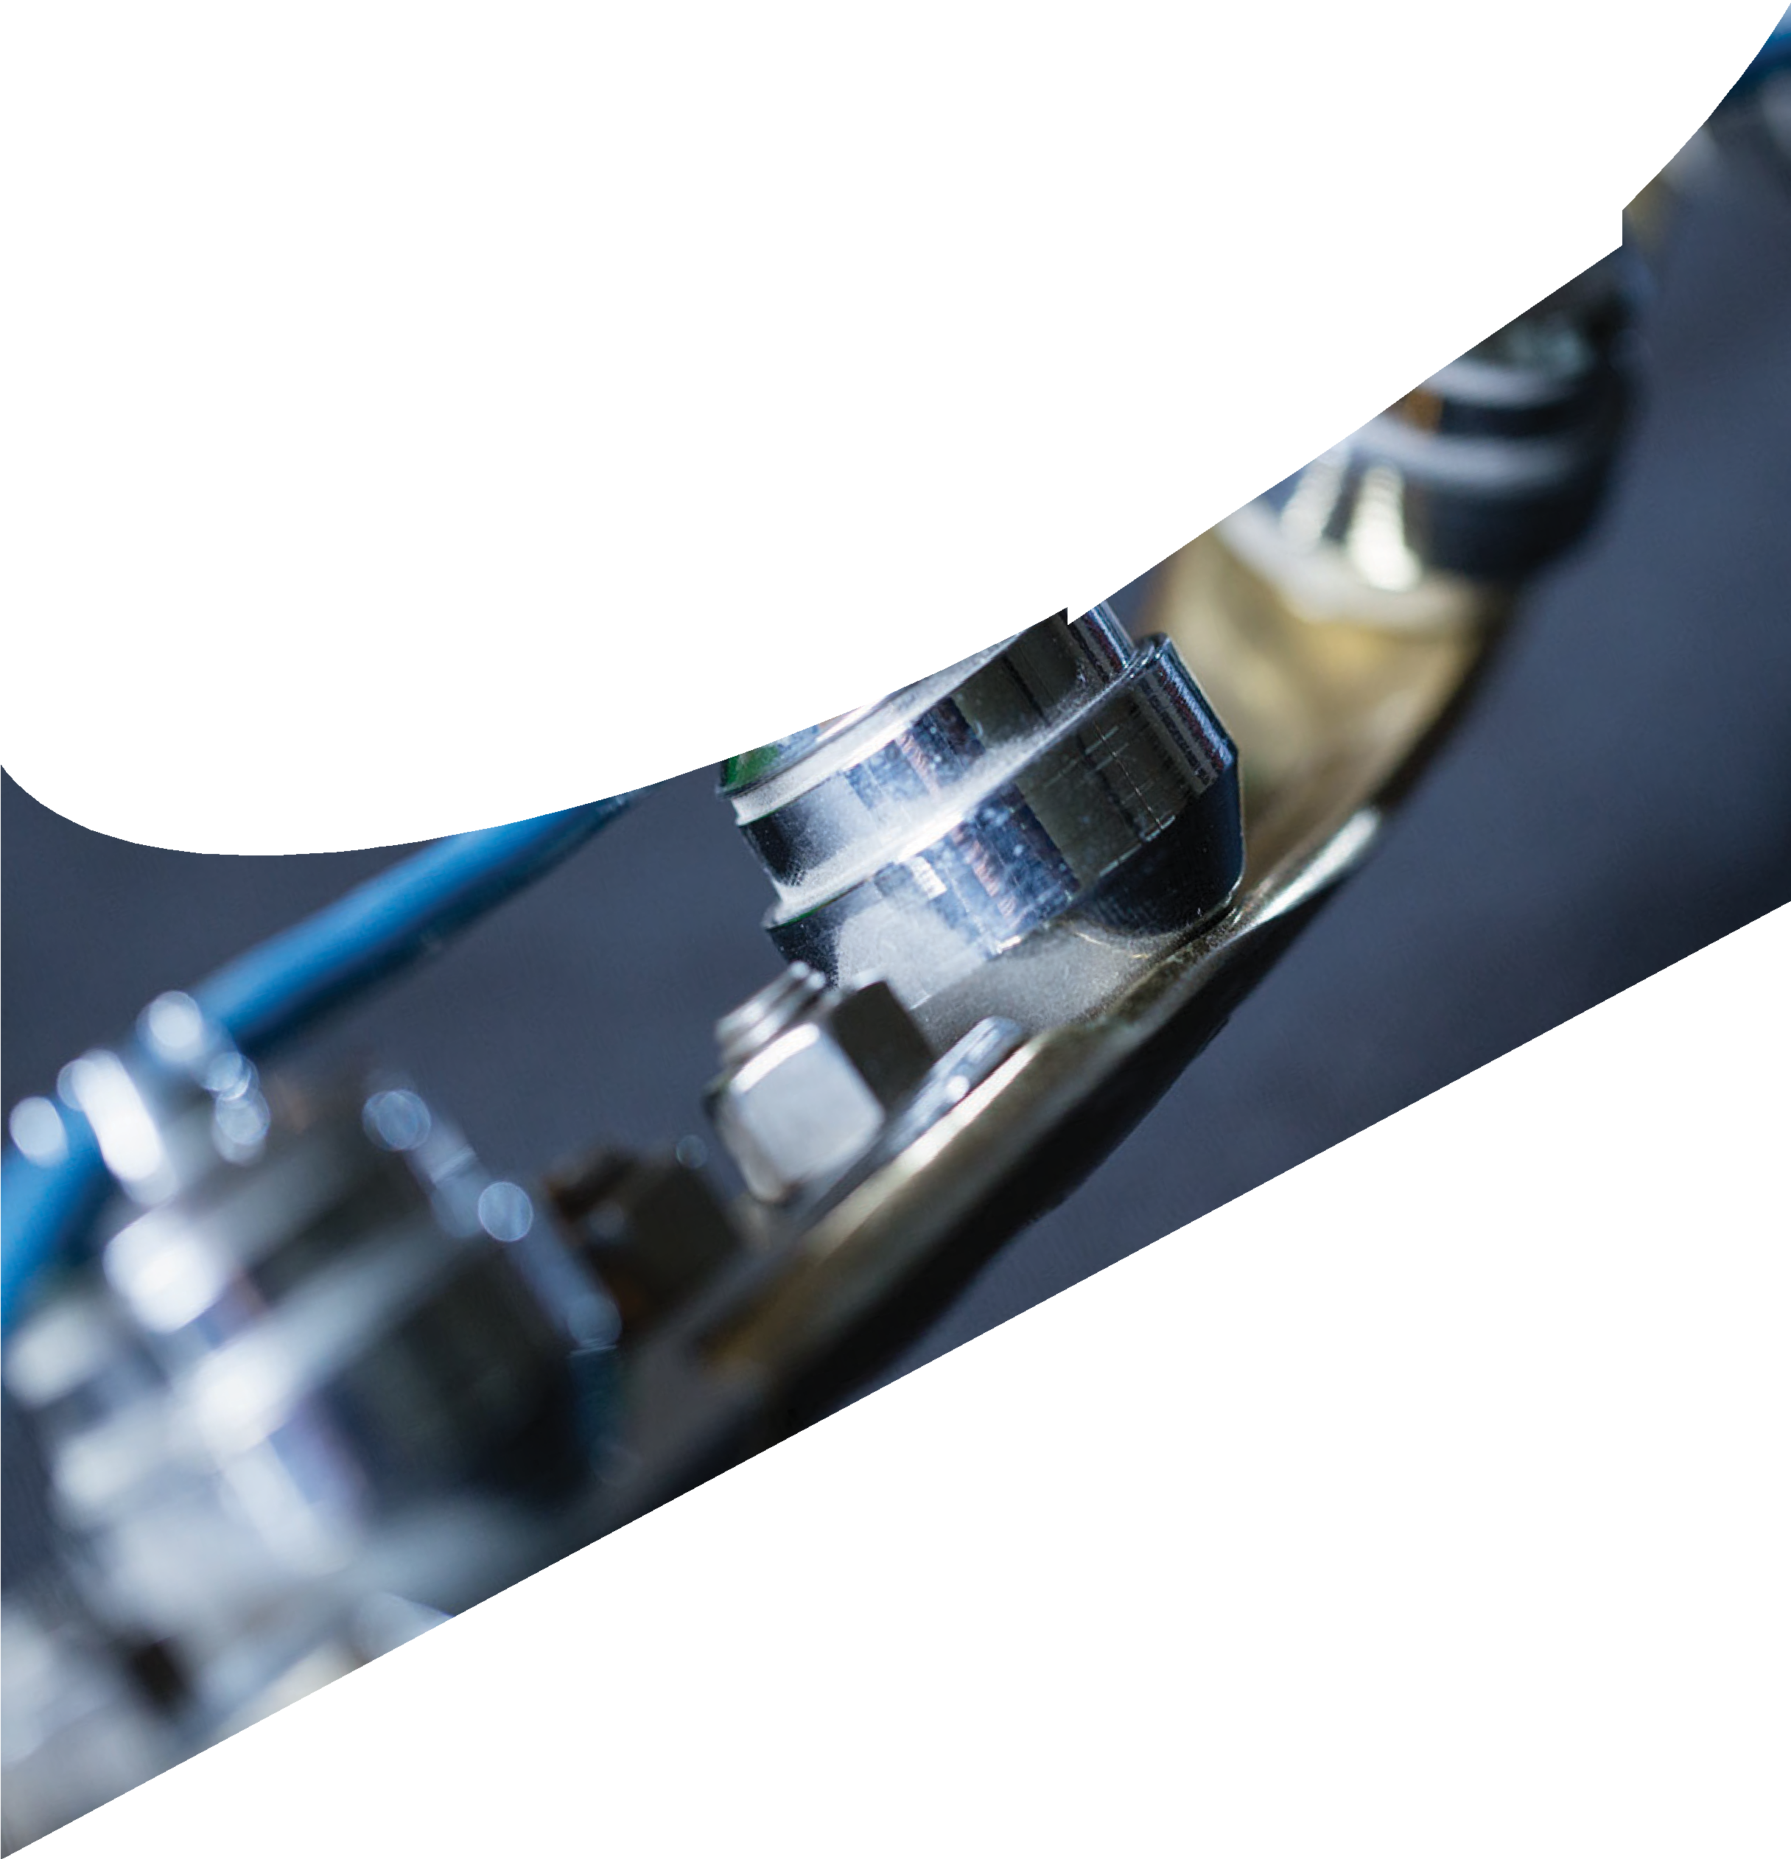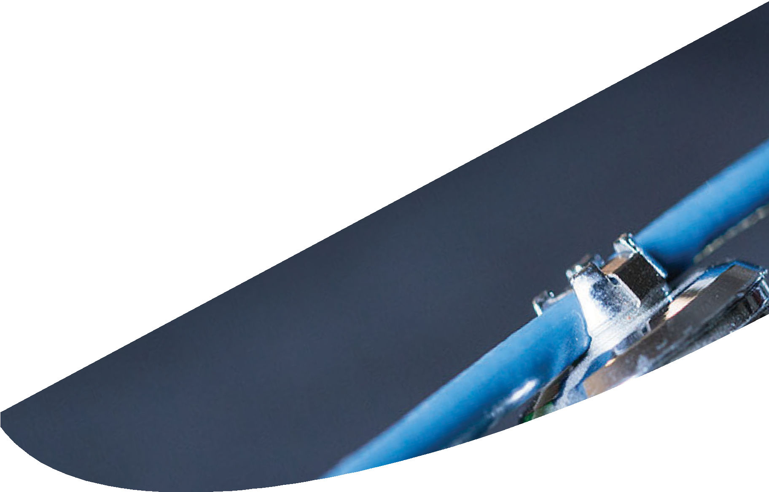

Asia Pacific Perforating Symposium
APPS 2018
MARCH 19-20,
2018
Kuala Lumpur Malaysia

Welcome to APPS 2018 in Kuala Lumpur, Malaysia!
You are invited to enjoy our technical program and take a moment to acknowledge our Sponsors, Presenters and Committee Members, who made this event posible.

Thank you, Clint Quattlebaum
John Davidson

APPS 2018 Co-Chairs: Clint Quattlebaum- Halliburton
John Davidson - Consultant

APPS 2018 Committee Members: Josh Lavery - Halliburton Nicholas Hendry- Shell Agung Cahyono - Corelab
Daniel Pastor - Hunting Titan Kerry Daly - Expro
Santosh Karunakaran - DynaEnergetics Chris Chalker - Geodynamics
Adil Al Busaidy - Schlumberger Yvonne Chung - Shell

Agenda | 2018 Asia Pacific Perforating Symposium
Sunday, March 18 Intercontinental Hotel, Kuala Lumpur, Malaysia
19:00 - 21:00 Dinner for Committee Members, Sponsors, and Presenters - Orchid & Dahlia

Monday, March 19 Junior Ballroom - Intercontinental Hotel, Kuala Lumpur, Malaysia

8:00 - 9:00 Registration

Opening Session
Clint Quattlebaum

9:00 - 9:15 Opening of Symposium
9:15 - 9:30 Safety Moment
9:30 - 9:45 Sponsor & Committee Recognition
Opening Speech: Malaysia Production Enhancement Landscape and Key

9:45 - 10:15
Challenges Wan A Aziz Wan Razali, Head of Production Technology, PETRONAS Malaysia Petroleum Management (MPM)

10:15 - 11:00 Break
Productivity Improvement Case Studies
Josh Lavery & Andrew Pettitt
11:00 - 11:30 Selection of perforation technique for brown fields: A novel approach
Vikash Kumar, Expro
Propellant-Assisted stimulation treatment to overcome near wellbore damage,

11:30 - 12:00
successfully executed in INDIA, a Case Study
Aditee Kulkarni, Baker Hughes a GE Company

12:00 13:00 Lunch
Explosives Safety
Adil Al Busaidy & Daniel Pastor
13:00 - 13:30 Recovery of Perforating Guns where the Explosives are Thermally Overexposed
Alphie Wright, Hunting Titan

Carbon Monoxide Hazards from Perforating During Plug and Abandonment

13:30 - 14:00

14:00 - 14:30
Operations
Brenden Grove, Halliburton
Is Shelf Life a Safety Consideration? A Case History Related to recent TCP Problem Incidents
Kerry Daly, Expro

14:30 - 14:45 Break
Novel Perforating Concepts
Kerry Daly & Santosh Karunakaran

14:45 - 15:15

15:15 - 15:45
Perforating Vertical Smart Well Completions Using Tubing-Conveyed Perforating Gun Assemblies: Case History
Josh Lavery, Halliburton
Autonomous Initiation Systems – Eliminating the Risks Associated with Downhole Conveyance
Adam Dyess, Hunting Titan

15:45 - 16:15 Real-time telemetric activation of slickline deployed perforating guns
John Creighton, Paradigm
16:15 - 16:30 Break
Perforation Testing
Nick Hendry & Chris Chalker

16:30 - 17:00

17:00 - 17:30
Shaped Charge Performance Evaluation Section IV - What is better Axial or Radial Flow?
Joern Loehken, DynaEnergetics
Successful use of API Section-IV Testing to Select between Zinc and Steel Case Shaped Charges in a Dual Zone Cased Hole Gravel Pack Tubing-Conveyed Perforating Operation for a Gas Well: Case Study
Mandeep Singh, Halliburton

Agenda | 2018 Asia Pacific Perforating Symposium
Monday, March 19 Junior Ballroom - Intercontinental Hotel, Kuala Lumpur, Malaysia
17:30 - 19:30 Advanced Analysis of Clean-up and Productivity from Perforated Rocks Using Computational Fluid Dynamics, Baker Hughes a GE Company
Multiple Operators in Asia-Pacific Region Improve Asset Value by Leveraging Perforation, Halliburton
Effective parameters on Oil well perforator and perforating gun design Mahmood Taheri, Demico

A Flow Laboratory Study of an Enhanced Perforating System Designed for Well Stimulation, Baker Hughes a GE Company

Configuring Dynamic Underbalance to Achieve Perforation Tunnel Cleanup in a Gas Well at High Static Overbalance Conditions, Halliburton
An Integrated Scientific Workflow Enables Successful Perforating Operations in Offshore Southeast Asia, Baker Hughes a GE Company
Tuesday, March 20 Junior Ballroom - Intercontinental Hotel, Kuala Lumpur, Malaysia
8:00 - 9:00 Registration
9:00 - 9:15 Opening Remarks John Davidson

Operational Efficiency Improvements
Kevin Anderson & Rahmat Wibisona
9:15 - 9:45 Advances in Detection of External Casing Cables During Perforating Operations
Iain Maxted, Guardian Global Technologies Ltd

9:45 - 10:15 Perforate or Stimulate?
Izura Aripin, Petronas Carigali Sdn Bhd
10:15 - 10:45 Crossflow May HIT Your Back!
Cheryl Perng, Murphy Oil Corp
10:45 - 11:00 Break

Perforation Modeling
Yvonne Chung & Agung Cahyono

11:00 - 11:30

11:30 - 12:00
Improving Existing Perforation Efficiency via Thru-Tubing Dynamic Underbalance Application in Offshore Field Malaysia
Lester Tugung Michael, Schlumberger
Validation and Application of a Next-Generation Dynamic Event Simulator for Perforated Completions
Jim Gilliat, Baker Hughes a GE Company

12:00 - 12:30 Closing Remarks

12:30 - 13:30 Lunch - Serena Brasserie
Explosives Safety
14:00 OTC Asia Opens at KLCC

Sponsors:
GOLD
tl
,, HUNTING
Hunting Titan
,
®

Care lab
RESERVOIR □PTIMIZAT I□N

nam1cs
I ®

DynaEnergetics™
\ J

HALLIBURTON

SILVER

